**YaraGo Products DBConnection Configuration Document**

**| Tomcat**

**1 Server.xml**

DB names should same in url attribute inside global naming resource

1.1 EMR(EMR Schema name)

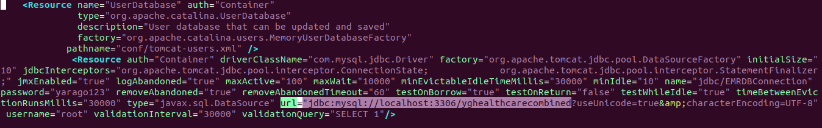

1.2 Ophthalstock(Ophthalstock Schema name)

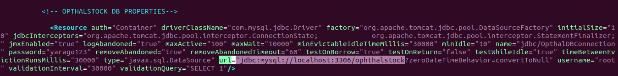

1.3 Opticals(Opticals Schema name)

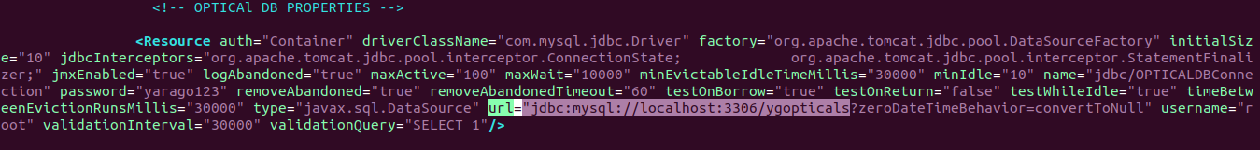

1.4 Pharmacy(Pharmacy Schema name)

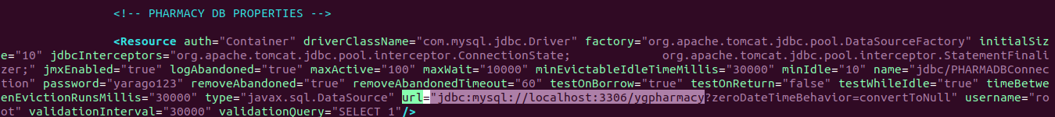

1.4 Insurance(Insurance Schema name)

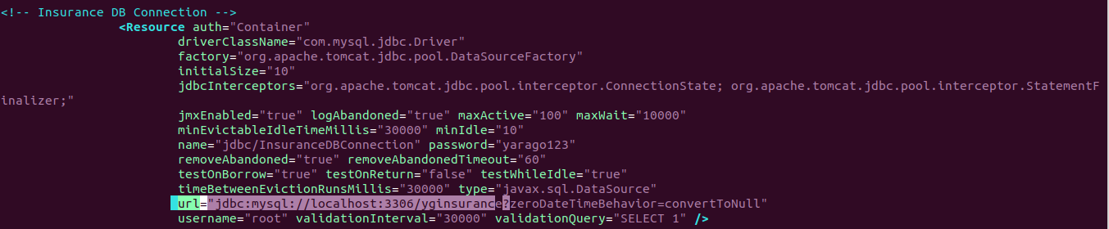

**|| War File DB Connections**

**1 yaragoemrjavaclient**

**web-inf->classes**

**datbase.properties**(EMR Schema name)

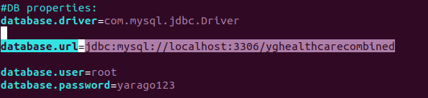

**2 yaragoadmin**

**web-inf->classes**

**database.properties**(EMR Schema name)



**3 ygemrservices**

**web-inf ->classes**

**hibernate.cfg.xml**(EMR Schema name)

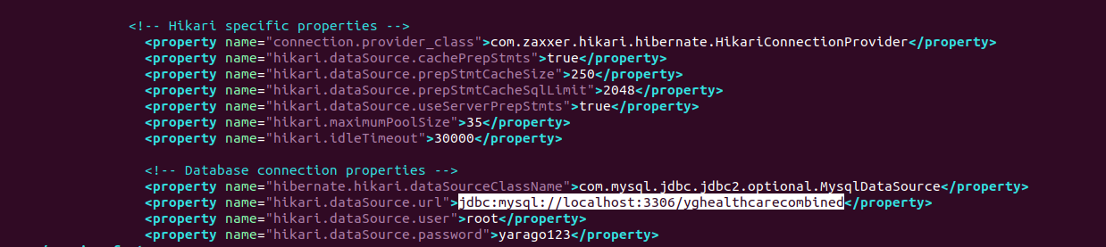

**hibernateOpticals.cfg.xml**(Opticals Schema name or EMR Schema name if customer not using Opticals)

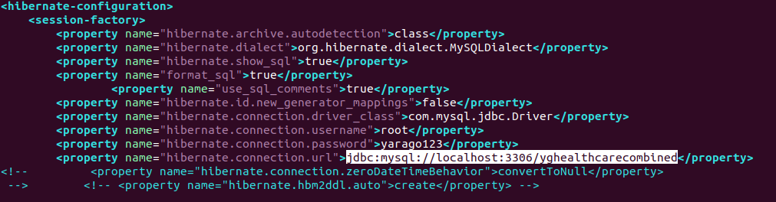

**4 ygopticals**

**web-inf->classes**

**hibernate.cfg.xml**(Opticals Schema name)

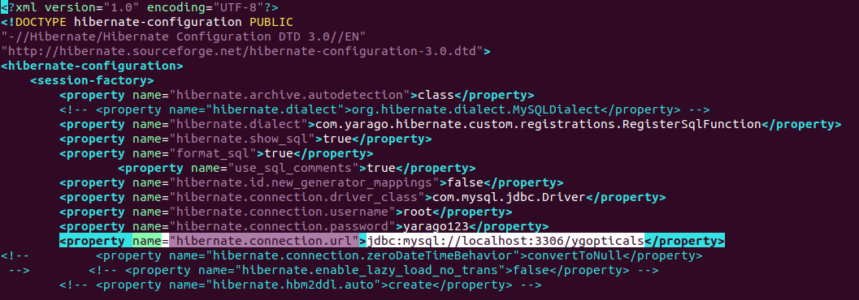

**hibernate.cfg_EMR.xml**(EMR Schema name)

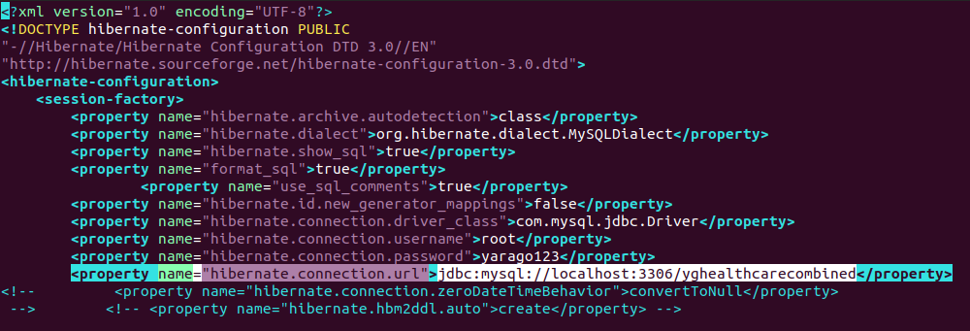

**5 ygpharmacy**

**web-inf ->classes**

**hibernate.cfg.xml**(Pharmacy Schema name)

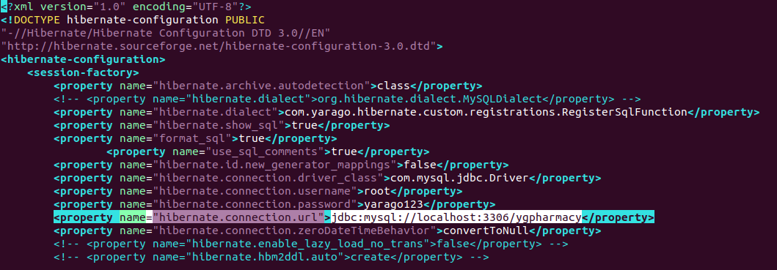

**hibernate.cfg_EMR.xml** (EMR Schema name)

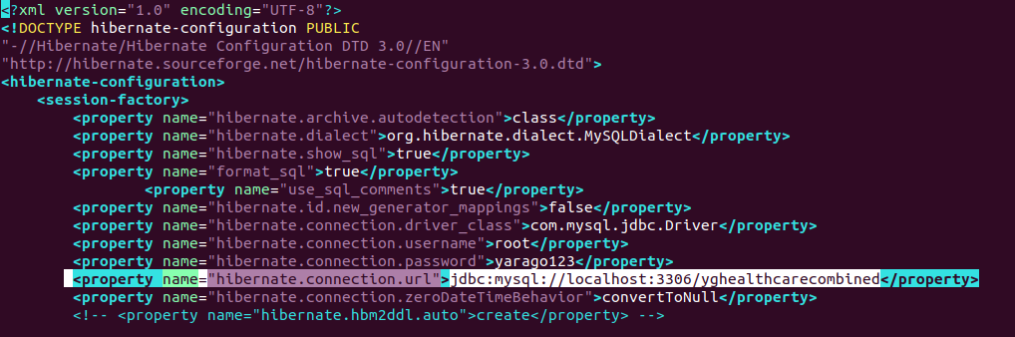

**6 yginsurance**

**web-inf -> classes**

**DB_Properties.properties**(Insurance Schema name)

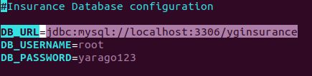

(EMR Schema name)

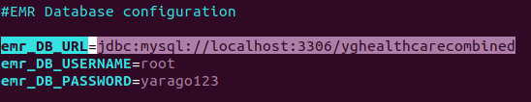

**7 ophthalstock**

**DB_Properties.properties**(Ophthalstock and EMR Schema name)

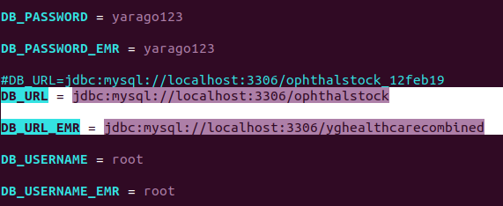

**||| Service Connections**

**1 Image Server (To connect Angular file deployed in Image Server and Service war file deployed in Tomcat)**

**1.1 ygopticals**

Open **main.c384a798e85793c069d5.js** in Notepad ++

Search ‘ygopticals’

IP address of Server system with port number of ygopticals deployed Tomcat



**1.2 ygpharmcy**

Open **main.afa767dd2287af72390c.js** in Notepad ++

Search ‘ygpharmacy’

IP address of Server system with port number of ygpharmacy deployed Tomcat



**2 ActiveMQ**(Communicating EMR with Opticals and Pharmacy)

**2.1 yaragoemrjavaclient**

**web-inf -> classes**

**mqSender.properties**

For Pharmacy port number 61616

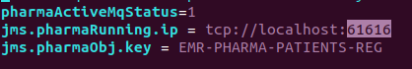

For Opticals port number 61716

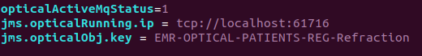

**2.2 ygopticals**

**web-inf -> ygopticals**

**application.properties**

Opticals port number 61716

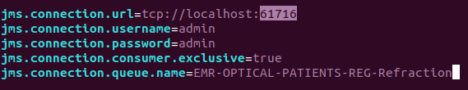

**2.3 ygopticals**

**web-inf -> ygpharmacy**

**application.properties**

Pharmacy port number 61616

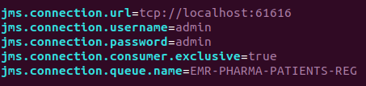

**V DB side connections**

**1 EMR Schema – tblhospitalpermitmodule**

**1.1 Insurance**

Mention Server system / Insurance deployed system IP address with Tomcat port



**1.2 Ophthalstock**

Mention Server system / Ophthalstock deployed system IP address with Tomcat port



**2 Insurance Schema – tbl_insurancebranch_app_db_configdetails**

Mention EMR deployed IP with port and Image path

