**BARCODE BROWSER SETTINGS**

**DB Configuration:**

1. **Give baracode generation configuration in below table:**

SELECT * FROM tbl_mst_barcode_config_details : nCategoryIdFk, barcodeCurrentValue, barcodePreviseValue, barcodeLength .

* **Login to chrome browser.**

1. Ctrl+ Shift + P = Print

**Print Setting**

* Select Respective printer **[ TSC TTP-244PRO]** and Click on Preferences

do below configuration.

\

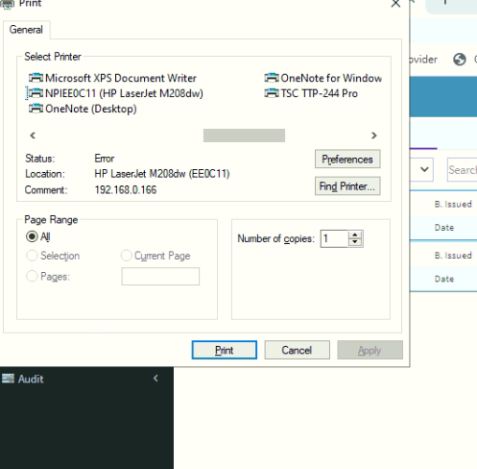

* Page setup

**Step 1.** New Newstock Name: opticals

|  |  |
| --- | --- |
| **Type** | De-Cut Lables |
| **Width** | 100.0mm |
| **Height** | 15.0mm |
| **Left**  **Right** | 0.00mm  22mm |

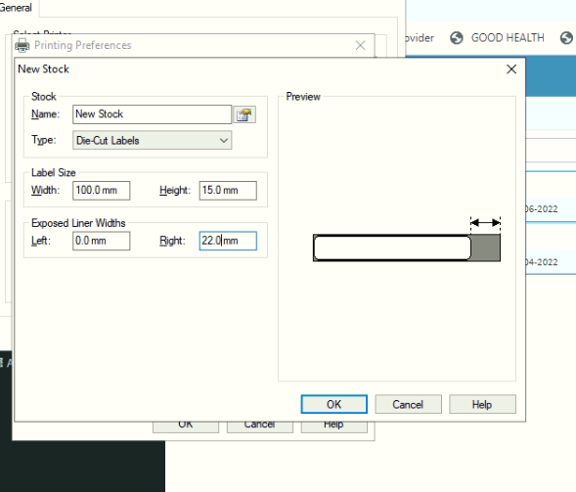

**Step 2** . In **Stock**

|  |  |
| --- | --- |
| **Method** | Thermal Transfer |
| **Type** | labels with Gaps |

**Step 3. In Graphics**

|  |  |
| --- | --- |
| **Graphics** | NONE |

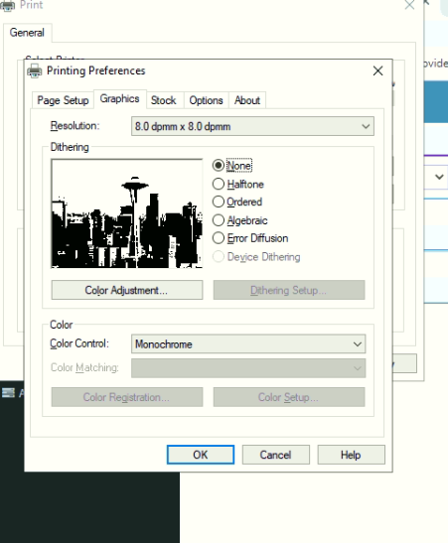

**Step 4.** Once done all setup Click Apply and OK

Login To YaraGo Opticals Application :

**Step 5.** Go to GRN – Received Goods

**Step 6.** Select any item Generate Barcode Save & print

**Step 7.** Printing screen

|  |  |
| --- | --- |
| **Designation** | TSC TTP-244pro |
| **Layout** | Portrait |
| **Margins** | Custom |
| **Scale** | Custom(60 to 65mm) |

