**EYE Drawing Configuration**

1**.Admin Warfile Changes** - Mention the path to upload images from Admin UI to Tomcat Images folder as EMR -> Examination screen is fetching from this Path

2.Ensure full permission given to Everyone for Tomcat installed drive.

**Step Number 1.**

**WarFileConfiguration:**

1. **Copy the path of yaragoemrjavaclient folder**

Ex: C:\Program Files\Apache Software Foundation\Tomcat7\webapps\yaragoemrjavaclient

1. Paste it into web.xml of **yaragoadmin** war file

Ex:Tomcat7>webapps>yaragoadmin>WEB-INF>Web.xml > **fileUploadPath**

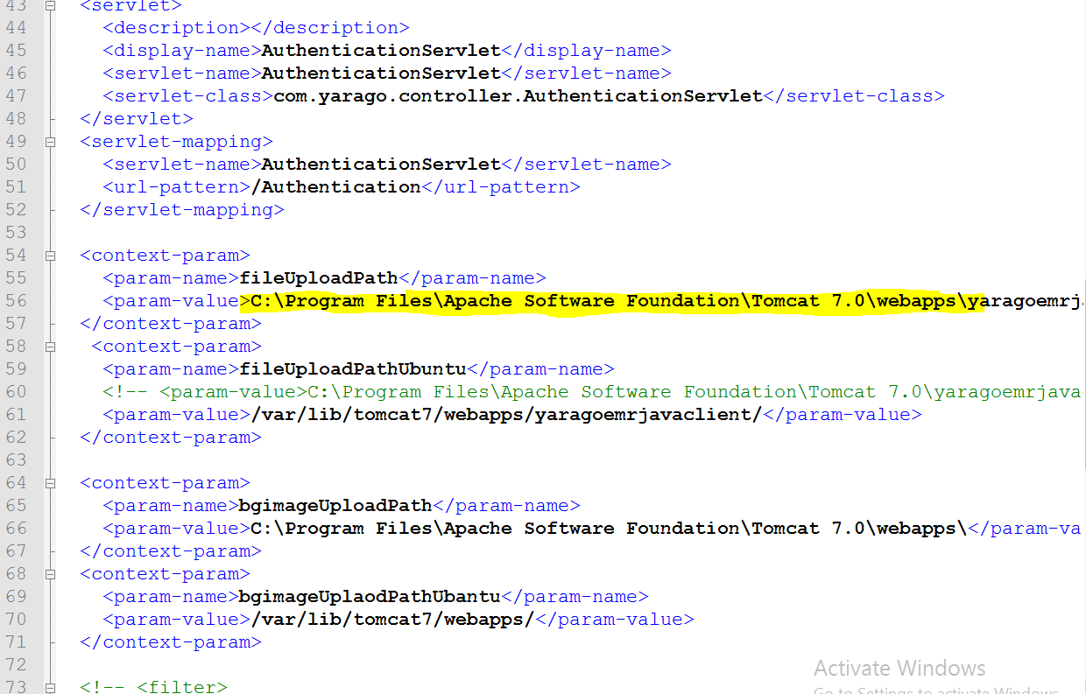

# Once Done delete extracted folder restart tomcat.

1. Give Folder Access permission of tomcat .

* Right click on Drive >Properties>Sharing>Advance Sharing>Permission>Enable Full Control Apply and ok

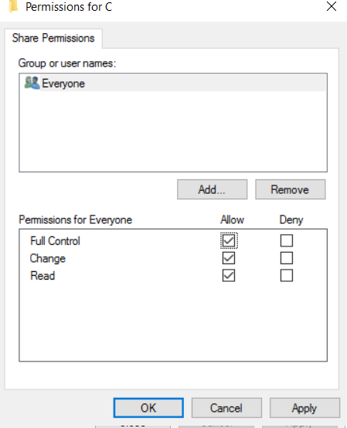

1. **To Upload EyeDrawings :** login to yaragoadmin page >Examination Master>[Eye Part Main](http://106.51.16.208:5050/yaragoadmin/welcome.jsp) Upload image for Eye part main and upload image .Login to EMR and verfify in Examination - Eye Drawing screen.

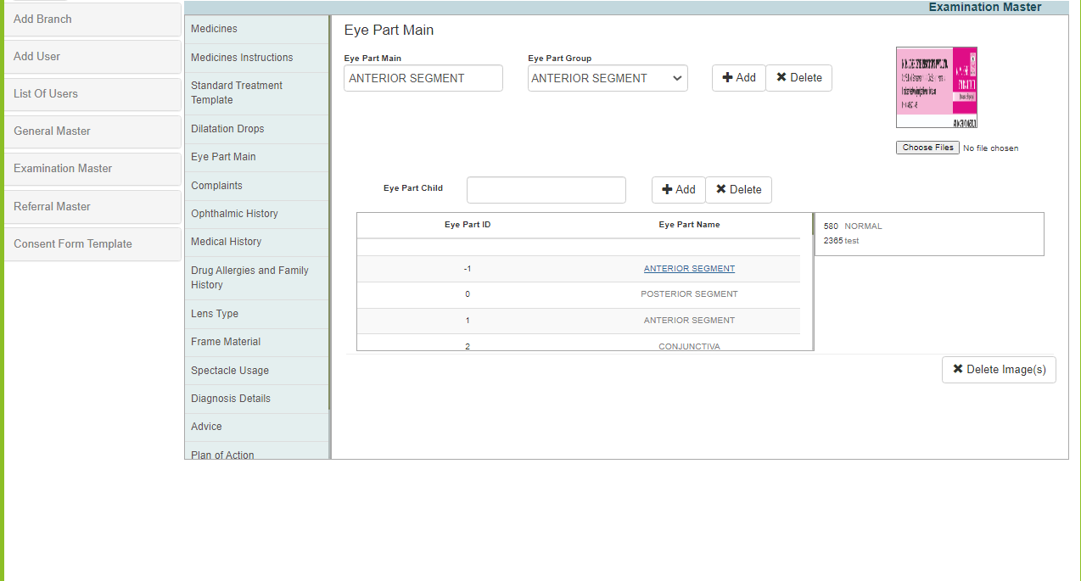

1. Uploaded image will be Saved in tbl_mst_eyepartimage after upload in admin.

* SELECT * FROM tbl_mst_eyepartimage;

1. Uploaded image will be saved in below path of tomcat 7

* C:Program Files>Apache Software Foundation>Tomcat >7.0>webapps>yaragoemrjavaclient>images

**Note** : In EMR Get of Eye Part image looks both from Table and tomcat