**Email Functionality Configuration**

**Steps:**

**1.Check host’s Email**

* First Need to Check whether Host email Working or not

**2. Set Email Parameters**

* We need to add host’s Email and Password in **tbl_mst_emailparameters**

**4. Encrypt the password by using given below API**

<http://localhost:7878/yaragoemrjavaclient/EMRServlet_Examination_7/> SendEmailPasswordEncrypt.do?password=K9618274710k

* Enter the encrypted password in **tbl_mst_emailparameters**
* Enter email_port(SMTP port)

Ex. For Gmail email_port= 465

7. Configuration for Gmail

Open gmail Goto security , Turn Off Less secure application

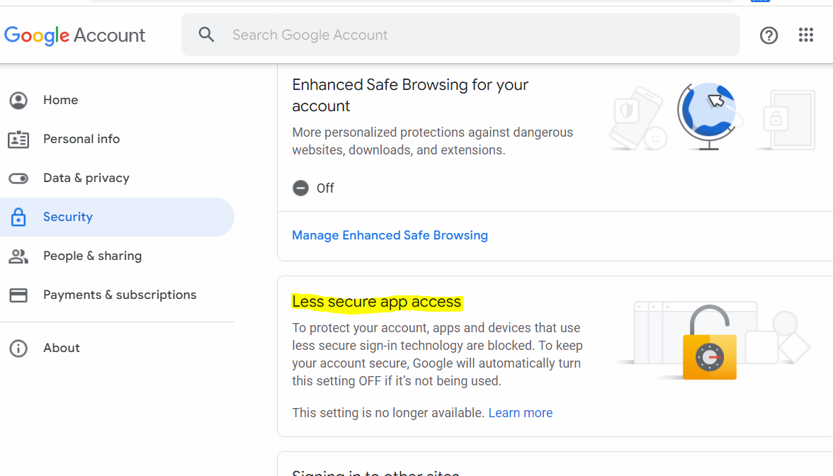

8**.** Add host’s mail ID in mail_cc column

9. In Hospital Permit module :

If the attached document need to be secured then set password by making isActive =’1’ in tblhospitalpermitmodule (**isPassWordRequiredForMailPDF**)

* if 1 is passwordRequired to open pdf and password should last four digits of MRD Number 0 not required