Consent Form Configuration

**Prerequisites:**

* **Image Server** should be installed to store the consent form uploaded from admin in **PrintTemplates** folder.
* **FTP Server** should be installed pointing to above **image server** to save and get the consent form

**Configuration :**

**Yaragoadmin War file Configurations :** To Upload Documents into image Server

* In file path property enter FTP Server System IP or Localhost,Username and Password of the System C:>Program Files>Apache Software Foundation>Tomcat7>webapps>yaragoadmin>WEB-INF>classes>filepath.properties

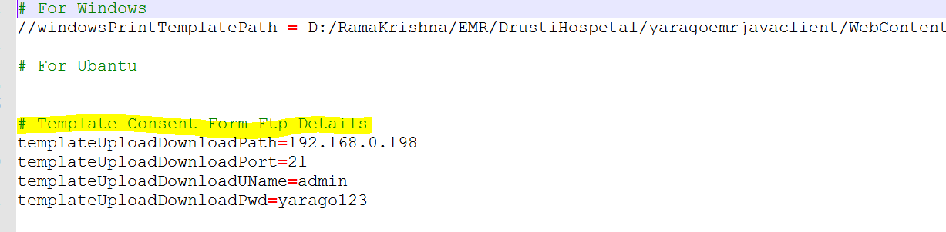

**Yaragoemrjavaclient War file Configurations :** To Display Consent forms in EMR To above FTP Server

* In file path property enter FTP Server System IP or Localhost,Username and Password of the System C:>Program Files>Apache Software>Foundation>Tomcat7>webapps>yaragoemrjavaclient>WEB-INF>classes>filepath.properties

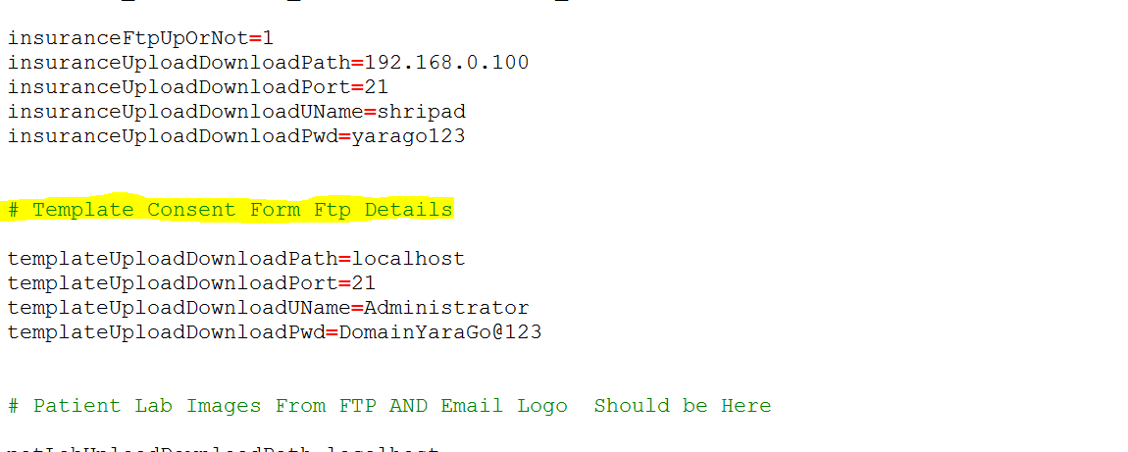

**Types Of Consent Template**

* **OPD Consent Template :**Will Display In Patient Demographics Module and shows always one consent form which is OPDConsent . If OPDConsent Template is not present then it takes First Surgey Consent Template

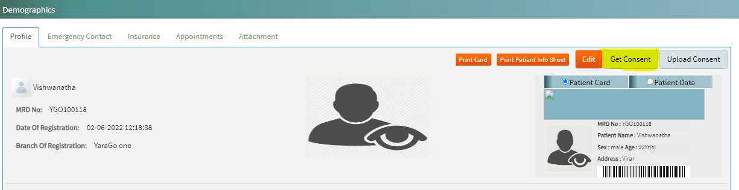

* **Surgery Consent Template:** Will display in Surgicals Appointment Lists and Counselling module.

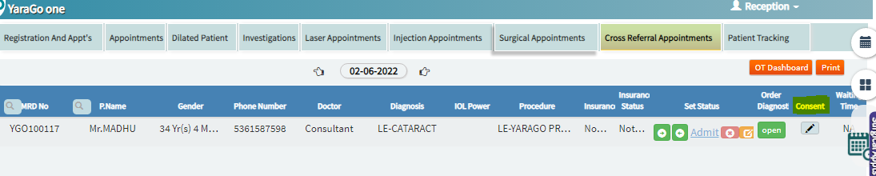

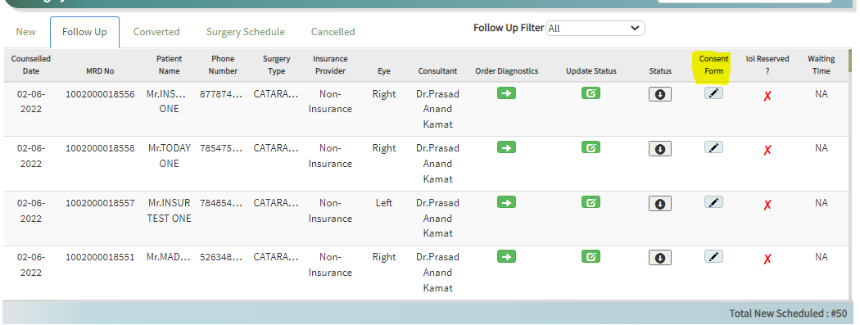

**URL To Translate the consent form From one language to other language:** **<https://translate.google.co.in/>**

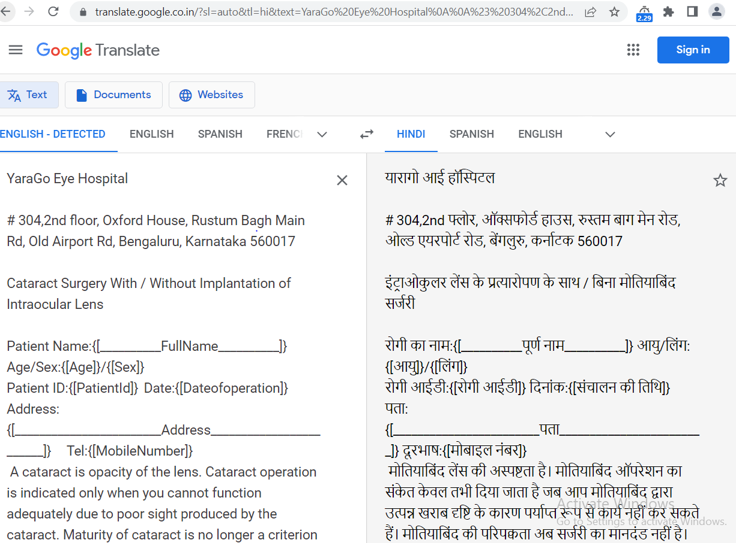

* **Adding consent form in Admin login :**

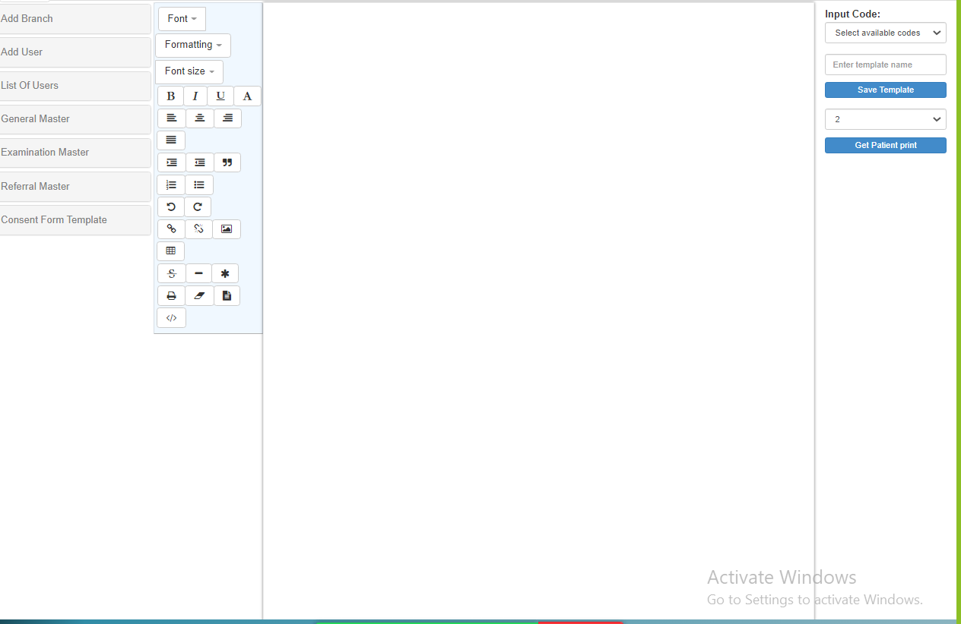

**Note:** Print header will be displayed with respect to branches using file name (1_ClientHeader) Which will be used in other print modules(Ex: Case History, Billing Etc.)