**Whatsapp Configuration**

**CONTENT:-**

1. **War File Side Changes.**
2. **Data Base Side Changes.**
3. **War File Side Changes:**

* **Add whatsUpUploadPath, Username and Password and whatsUpfildownload in mqSender.Properties of yaragoemrjavaclient warfile.**

**In warfile path: Tomcat7>Webapps>yaragoemrjacvaclient>WEB-INF>classes> mqSender.Properties**

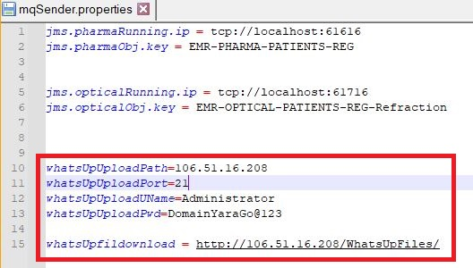

* **NOTE: For fileupload IP should Public(need to do Port Forwarding in router)**

**Data Base Side Changes:**

* **In tblhospitapermitmodule table :**

**moduleName = 'isWhatsAppEnabled' make isActive=1,**

**moduleName = isWhatsAppPatientRegistrationText’ make isActive=1,**

**(urlType=1)**

**moduleName = ‘isWhatsAppRxMedicineAttachment’ make isActive=1,**

**(urlType=2)**

**moduleName = ‘isWhatsAppRefractionsAttachment’ make isActive=1,**

**(urlType=3)**

**moduleName = ‘isWhatsAppCaseHistoryPrintAttachment’ make isActive=1,**

**(urlType=4)**

**moduleName = ‘isWhatsAppOPDBillPrintAttachment’ make isActive=1,**

**(urlType=5)**

**moduleName = ‘isWhatsAppIPDBillPrintAttachment’ make isActive=1,**

**(urlType=6)**

**moduleName = ‘isWhatsAppAdvanceReceipttext’ make isActive=1,**

**(urlType=7)**

**moduleName = ‘isWhatsAppIPDAdvanceReceiptPrintAttachment’ make isActive=1, (urlType=8)**

**moduleName = ‘isWhatsAppFollowUpAppointText’ make isActive=1,**

**(urlType=9)**

**moduleName = ‘isWhatsAppDischargePatientText’ make isActive=1,**

**(urlType=10)**

**moduleName = ‘isWhatsAppSurgicalAppointmentText’ make isActive=1,**

**(urlType=11)**

**moduleName = ‘isWhatsAppOPDBillDetailsText’ make isActive=1,**

**(urlType=13)**

**moduleName = ‘isWhatsAppDischargePatientAttachment’ make isActive=1**

**(urlType=14)**

* **In tbl_mst_whatsapp_sms_credential table :**

**Add values in ‘urlType’, ‘messageType’, ‘smsUrl’ and ‘message’.**

**SMS URL’s:**

**For : messageType =’text’**

**SMS URL: “https://wauto.us/api/send.php?access_token=53668e848b6d9eb95f33233029ba726d&instance_id=63E7A7EF7D4B9&number=91PATMOBILENUMBER&type=text&message=MESSAGETOSEND”**

**For: messageType =’pdf’**

**SMS URL:**

**“https://wauto.us/api/send.php?access_token=53668e848b6d9eb95f33233029ba726d&instance_id=63E7A7EF7D4B9&number=91PATMOBILENUMBER&type=media&message=MESSAGETOSEND&media_url=UPLOADFILEPATH&filename=BILL”.**

**Parameters in message:**

**TYPEMESSAGETOSEND,**

**MESSAGETOSEND,**

**USERNAMEFORLOGIN,**

**PASSWORDFORLOGIN,**

**SENDERRIDFORLOGIN,**

**PATMOBILENUMBER,**

**PATIENTNAME,**

**PATIENTMRDNUMBER,**

**UPLOADFILEPATH,**

**HOSPETALDOCTORNAME,**

**UPLOADFILENAME,**

**PATADVANCEPAYABLEAMOUNT,**

**PATADVANCEAMOUNT,**

**PATADVANCEREMAININGAMOUNT,**

**PATFOLLOWUPDOCTORNAME,**

**PATFOLLOWUPAPPOINTMENTTIME,**

**PATSURGICALAPPOINTSURGNAME,**

**PATSURGICALAPPOINTOPERATEDDATE,**

**PATOPDBILLTOTALAMOUNT.**

**Example:- For Patient Registration:**

**“Hi This PATIENTNAME with your mrd no PATIENTMRDNUMBER”.**

* **In tb_whatsapp_sms_transactions_details table :**

**We are Updating API trace and smsResponseMessage.**

* **NOTE: Password is last four digit of MRD Number (to open the file)**
* **In tblhospitapermitmodule table :**

**moduleName = 'IsPasswordrequiredforWhatsAppAttachment' make isActive=1**

**(To open file with password)**

**moduleName = 'IsPasswordrequiredforWhatsAppAttachment' make isActive=0**

**(To open file without password)**